Party Sobriety analyzation

The objective of analyzing the data given from the parties table was to determine if the majority of the parties were under the influence at the time of their collisions. In addition, we also had an interest in determining the percentage contribution of the types of parties that were found at fault for their collisions.

After analyzation of the party sobrieties at the time of their collisions, it has been determined that most of the parties involved in collisions were not under the influence which can be seen in the figure below. The total number of parties that had not been drinking prior to their collision amounted to a total of 14,232,676 parties. This information considers all the recorded collisions throughout every county of California.

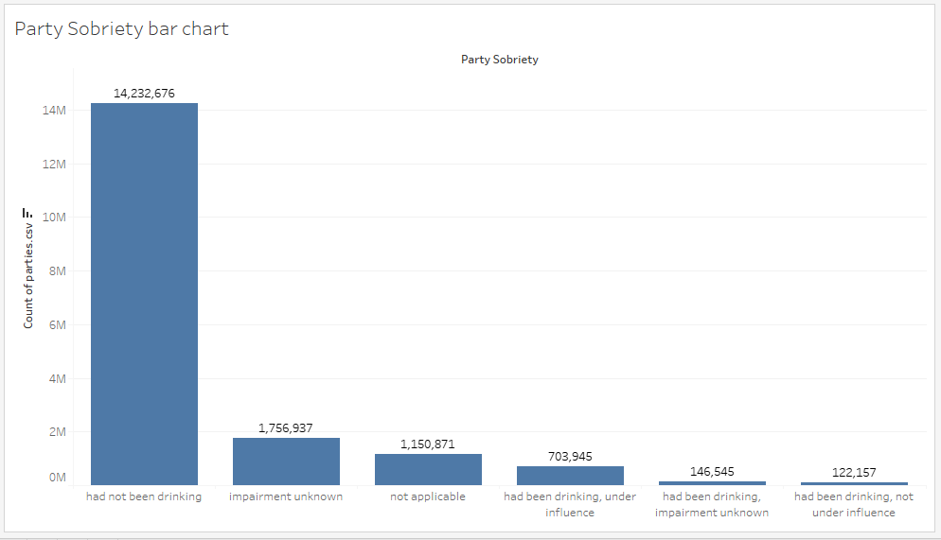

Bar graph showing the different amount of party sobrieties recorded throughout the state of California. Sobrieties were recorded at or around the time collisions occurred.

Party at fault analyzation

Additionally, there was an interest in analyzing the party types that were found at fault for the collisions they were involved in. Using the data recorded for the parties involved, a pie chart was created to compare the distribution of party types that were found at fault. As can be seen in the pie chart figure below, the majority of the party types that were found at fault were parties that were driving cars. Drivers were calculated at 96.90% of the party types that were found at fault. Bicyclists were calculated at 1.69%, pedestrians were calculated at 1.15%, and parked vehicles were 0.11%. This information also considers all the recorded collisions throughout every county of California.

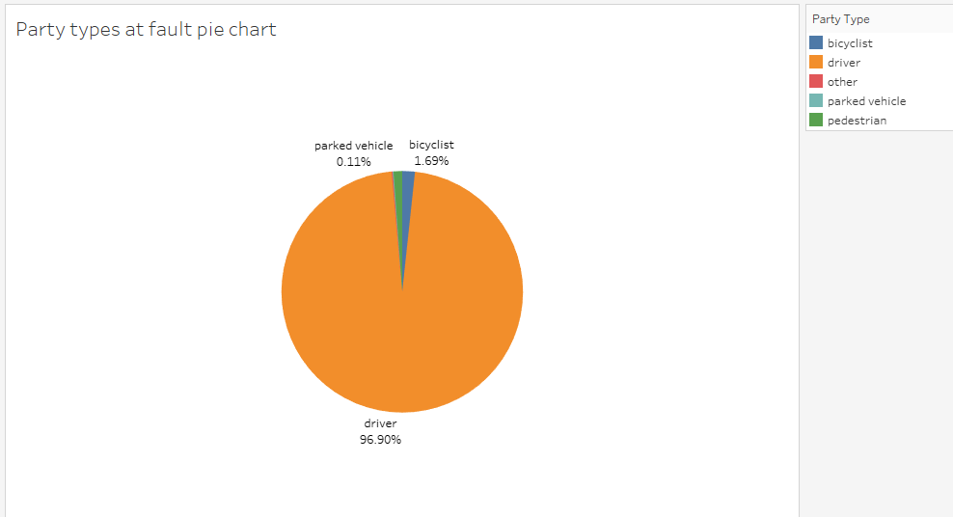

Pie chart showing the distribution of party types that were found at fault of their collisions. Distribution is calculated by percentage of total.